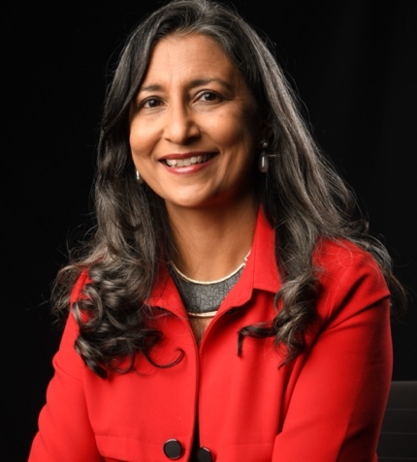
RACHPAL KAUR TULSI
Associate Trainer/Developer
Qualifications
MA (Education & Human Development)
BA (Psychology & Politics)
Neuro-Linguistic Programming (NLP) Master Certification
Enneagram Personality Profiling Trainer
DISC Certified Trainer
Blue Belt in Systems Thinking
Harrison Assessment Tools
Coaching Certification (John C Maxwell)
Advanced Certificate in Training and Assessment (ACTA)
Specialisations
- Service Excellence and People Management
- Sensemaking and Data Analytics
- Leadership & Communication
- Organisational Change Management
- Leading Multicultural and Diverse Workplace
- Mental Wellness & Mindfulness at the Workplace

Rachpal Kaur Tulsi has over 25 years’ experience in training, customer service, organisational development, mentoring and coaching. As a Consultant, Rachpal has had extensive experience working with top management to conceptualise strategies for communicating the organisational mission and vision to its employees and the successful immersion of new employees to the organisation.

Rachpal specialises in delivering training programmes for developing personal and organisational leadership through changing beliefs and mindset. Organisations that have engaged her services include Fortune 100 Company and a wide range of sectors such as health, marine, oil and gas, network and telecommunication and financial services.
Rachpal has extensive experience in coaching both Senior Management and High-Potential Executives in reviewing their performance and coaching them on areas for development using 360-degree feedback, performance management standards and other tools. She has conducted organisational development work identifying performance gaps and providing solutions through on-site consultancy and/or training in change management, leadership skills, effective communication and mindfulness and resiliency.
Rachpal has also trained personnel in service training ranging from dealing with customers, managing difficult customer situations, managing telephone service and service excellence. She has extensive experience in training personnel from both the public and private sector.
Some key clients she has worked with are Rolls Royce (Marine), Sembcorp, Hamworthy (now Wartsila), Housing and Development Board, Ministry of Defence, Ministry of Manpower.
Rachpal has also been trained in Systems Thinking by Cabrera Research Lab (accredited to the System Thinking Standards Institute) and a coaching certification from John C Maxwell.

Among the organisations that she has worked with are:

Government and Statutory Board (Singapore)  - Ministry of Defence  - Ministry of Home Affairs  - Ministry of Health  - Ministry of Finance  - Ministry of Community, Youth and Sports  - Land Transport Authority  - Social Services Training Institute  - Singapore Corporation of Rehabilitation Services (SCORE)  - Urban Redevelopment Authority  - Housing and Development Board  - Civil Service College  - National Council of Social Service  - Amalgamated Union of Public Employees (AUPE)  - Singapore Tourism Board  Government (Overseas)  - Government representatives from various countries in Africa  - Office of the Presidential Secretariat (Sri Lanka)  Information Technology and Networking  - CISCO Asia Pacific  - Fermat Singapore  - Sarir International (Iran)  - Hewlett-Packard (Singapore)  - AutoDesk  - Here Solutions (Nokia) (Philippines)  Educational Institutions  - Singapore University of Technology and Design (SUTD)  - Singapore Institute of Management  - Marketing Development Institute of Singapore (MDIS)  - Marketing Institute of Singapore (MIS)  - Jurong West Secondary School  - Telok Kurau Secondary School  - National Institute of Education  - Singapore Polytechnic  - Institute of Technical Education (ITE)  Telecommunications  - Singtel  - Dhiraagu Pte Ltd (Maldives)  - Here Solutions (Philippines)  Logistics/Transportation  - Panalpina (Singapore, Malaysia, Indonesia)  - ComfortDelgro | Marine and Oil and Gas  - Eastern Pacific Shipping  - Hamworthy Singapore  - SembCorp  - Safety at Work (a safety consultant of Shell Singapore)  - Cameron Singapore  - Rolls Royce Marine (China/South Korea)  - Svitzer Salvage Asia Pte Ltd  Healthcare  - National Heart Centre  - Ministry of Health  - Institute of Mental Health  Banking and Financial Sector  - United Overseas Bank (UOB)  - StanChart (Singapore)  - SingCapital (Agency)  - Prudential (Agency)  - China Insurance (Singapore)  - Financial Women’s Association  Insurance  - Canopius Asia Pte Ltd  - Allianz  Flavours and Fragrances  - Firmenich Singapore  - Nestle Singapore  Engineering/Electronics/Semi-conductors  - Panasonic  - DMG/Mori-Seiki  - Renasas Semiconductor Singapore  - LAM Research  - FARO Pte Ltd  - Hewlett Packard  - Tanaka  Pharmaceutical  - Bohreinger-Ingelheim  Publishing  - John Wiley  Sports/Apparel/Fashion  - Hugo Boss  - B.P. de Silva  - Under Armour

A summary of her trainings she has conducted are as follows:

- Diversity, Equity and Inclusivity (DEI)  - Critical Thinking and Sensemaking  - Change Management  - Reframing – Developing a Different Perspective  - Cultural Diversity and Inclusivity at the Workplace  - Mindfulness and Resilience Enneagram for Workplace Excellence  - Coaching and Mentoring Skills for Managers  - Developing Workplace Effectiveness with Neuro Linguistic Programming | - Effective Communications Skills  - Stakeholder Management (Customer Requirement Analysis)  - Developing a Customer Service Strategy  - Service Motivation and Leadership  - Managing Conflict in Your Team  - Problem Solving  - Developing a Work-Life Balance  - Management Development Program  - Professionalism at the Workplace  - Presentation Skills  - Personal Branding  - Team Building and Understanding Team Dynamics

